DATA SCIENCE MINOR PROJECT REPORT
Project Title: Glioma Grading Clinical and Mutation Features
Submitted by: Sangam Srivastav
Submitted to: Mr. Manpreet Singh Sehgal
Registration No: 12323431
Section & Roll No. : K23SG , 18
Course Code: INT 375
Under the Guidance of: Mr. Manpreet Singh Sehgal
Discipline of CSE/IT
Lovely Professional University, Phagwara

DECLARATION
I am, Sangam Srivastav, a student of CSE/IT Discipline at Lovely Professional University, Punjab, hereby declare that all the information furnished in this project report is based on my own intensive work and is genuine.
Date: 12-04-2025
Signature: Sangam Srivastav

CERTIFICATE
This is to certify that Sangam Srivastav has completed the project titled, “Glioma Grading Clinical and Mutation Features” under my guidance and supervision. To the best of my knowledge, the present work is the result of his original development, effort, and study.
Signature and Name of the Supervisor:
Mr. Manpreet Singh Sehgal
School of Engineering
Lovely Professional University
Phagwara, Punjab
Date: 12-04-2025

ACKNOWLEDGEMENT
I sincerely thank my mentor for their valuable support and guidance throughout the course of this project. I also acknowledge the university and faculty for providing access to resources and a conducive learning environment. Finally, I extend my gratitude to my peers and family for their encouragement.

TABLE OF CONTENTS
- Introduction
- Source of Dataset
- EDA Process
- Analysis on Dataset
i. Introduction
ii. General Description
iii. Specific Requirements, Functions and Formulas
iv. Analysis Results
v. Visualization
- Conclusion
- Future Scope
- References

1. Introduction
This project analyzes clinical and genetic mutation data from glioma patients (GBM and LGG) using data science techniques. The main aim is to study how different features such as age, gender, race, and mutation profiles correlate with glioma grading. The findings may help in better understanding the disease progression and treatment planning.

2. Source of Dataset
The dataset is obtained from the UCI Machine Learning Repository:
Glioma Grading Clinical and Mutation Features Dataset

3. EDA Process
- Missing values were identified and handled appropriately.
- Columns like age at diagnosis were converted from days to years for clarity.
- Data types were standardized for processing.
- Categorical variables such as gender, race, and grade were labeled for clarity in visualization.
- Mutation frequency was assessed using the 20 most commonly affected genes.

4. Analysis on Dataset

Objective 1: Grade Distribution(Count of GBM vs LGG)
General Description: Compare LGG vs GBM count
Functions/Tools Used: Pandas value_counts(), barplot
Result: LGG cases outnumber GBM cases
Visualization: Bar chart showing grade counts

grade_counts = df['Grade'].value_counts()
plt.figure(figsize=(6, 4))
grade_counts.plot(kind='bar', color=['skyblue', 'salmon'])
plt.title('Distribution of Glioma Grades')
plt.xlabel('Grade (0 = LGG, 1 = GBM)')
plt.ylabel('Number of Patients')
plt.grid(True)
plt.show()
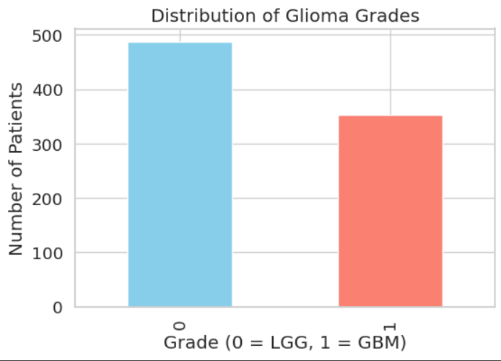

Objective 2: Gender Distribution
General Description: Analyze gender-wise representation
Functions/Tools Used: value_counts(), seaborn countplot
Result: Slightly more males than females
Visualization: Bar chart by gender
gender_counts = df['Gender'].value_counts()
plt.figure(figsize=(6, 4))
gender_counts.plot(kind='bar', color=['lightgreen', 'lightcoral'])
plt.title('Gender Distribution')
plt.xlabel('Gender') # Avoid hardcoding labels until we know encoding
plt.ylabel('Count')
plt.grid(True)
plt.show()
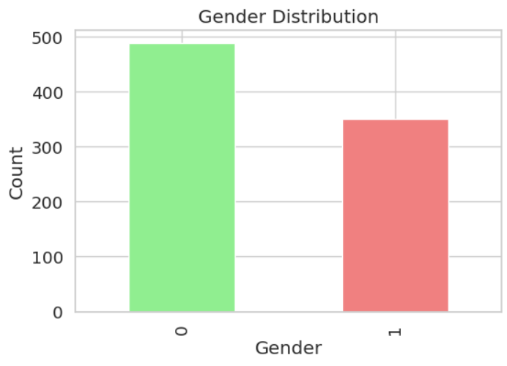

Objective 3: Race Distribution
General Description: Show how race varies among patients
Functions/Tools Used: value_counts(), countplot
Result: Most patients were White; other races less frequent
Visualization: Bar chart by race
race_counts = df['Race'].value_counts()
plt.figure(figsize=(8, 5))
race_counts.plot(kind='bar', color='purple')
plt.title('Race Distribution')
plt.xlabel('Race')
plt.ylabel('Number of Patients')
plt.grid(True)
plt.show()
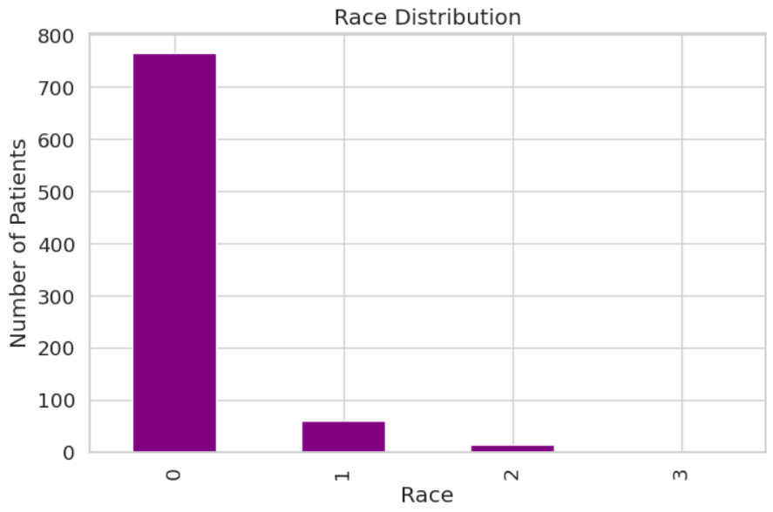

Objective 4: IDH1 Mutation by Grade
General Description: Compare IDH1 mutation presence across grades
Functions/Tools Used: crosstab, stacked barplot
Result: IDH1 mutations are more common in LGG
Visualization: Stacked bar chart
idh1_dist = df.groupby(['Grade', 'IDH1']).size().unstack(fill_value=0)
plt.figure(figsize=(6, 4))
idh1_dist.plot(kind='bar', stacked=True, color=['grey', 'blue'])
plt.title('IDH1 Mutation Distribution by Grade')
plt.xlabel('Grade')
plt.ylabel('Patient Count')
plt.grid(True)
plt.show()
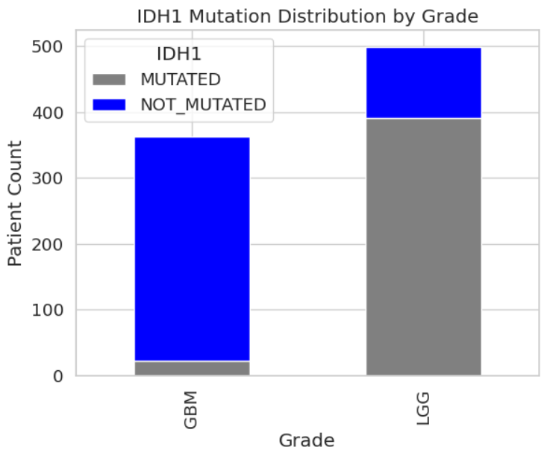
Objective 5: TP53 Mutation Status
General Description: Pie chart of mutation status
Functions/Tools Used: value_counts(), plt.pie
Result: Balanced proportion of mutated and non-mutated
Visualization: Pie chart
tp53_counts = df['TP53'].value_counts()
plt.figure(figsize=(6, 6))
plt.pie(tp53_counts, labels=['Not Mutated', 'Mutated'], autopct='%1.1f%%', colors=['lightgray', 'red'])
plt.title('TP53 Mutation Status')
plt.show()
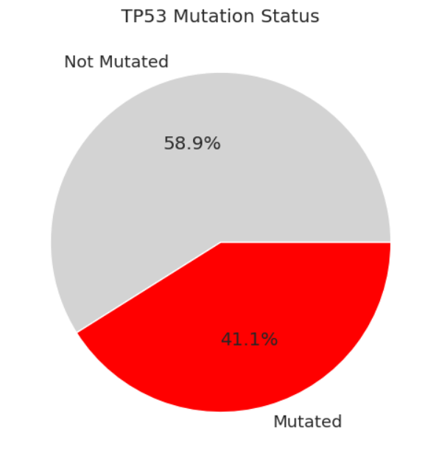

Objective 6: Race-wise Grade Distribution
General Description: Cross-tabulation by race and grade
Functions/Tools Used: pd.crosstab(), stacked bar chart
Result: White patients dominate both grades
Visualization: Bar chart by race and grade
race_grade = pd.crosstab(df['Race'], df['Grade'])
plt.figure(figsize=(8, 6))
race_grade.plot(kind='bar', stacked=True, colormap='viridis')
plt.title('Grade Distribution across Races')
plt.xlabel('Race')
plt.ylabel('No.of Patients')
plt.grid(True)
plt.tight_layout()
plt.show()
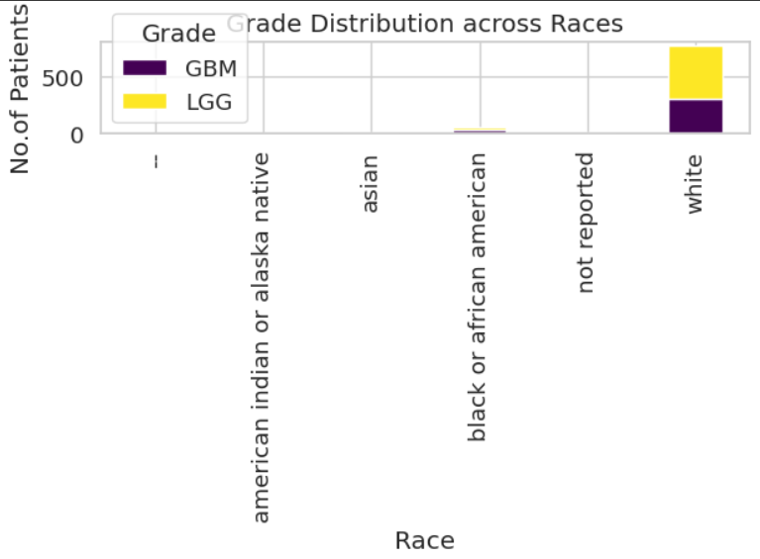

Objective 7: Boxplot of Age by Grade
General Description: Show age distribution by grade
Functions/Tools Used: boxplot
Result: GBM age range is slightly older
Visualization: Boxplot
plt.figure(figsize=(8, 6))
sns.boxplot(x='Grade', y='Age_at_diagnosis', data=df, palette=['#1f77b4', '#ff7f0e'])
plt.title('Age Distribution by Glioma Grade')
plt.xlabel('Grade (0 = LGG, 1 = GBM)')
plt.ylabel('Age at Diagnosis (Years)')
plt.xticks([0, 1], ['LGG', 'GBM'])
plt.show()
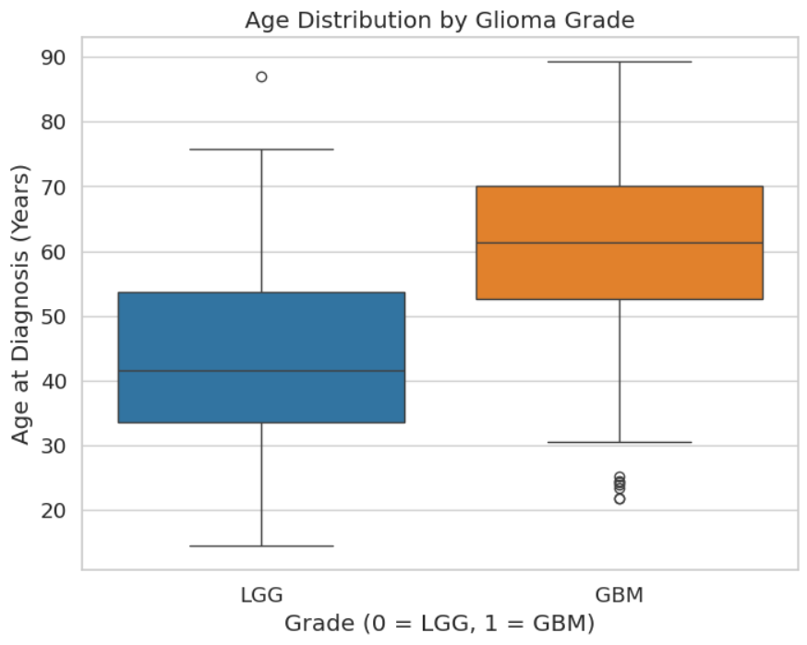
Objective 8: Violin Plot – Mutation Count per Patient
General Description: Compare mutation burden by grade
Functions/Tools Used: sum(axis=1), violinplot
Result: Mutation burden differs between LGG and GBM
Visualization: Violin plot
df['Mutation_Count'] = df[mutation_cols].sum(axis=1)
plt.figure(figsize=(8, 6))
sns.violinplot(x='Grade', y='Mutation_Count', data=df, palette=['#1f77b4', '#ff7f0e'])
plt.title('Mutation Count Distribution per Patient by Grade')
plt.xlabel('Grade (0 = LGG, 1 = GBM)')
plt.ylabel('Number of Mutations')
plt.xticks([0, 1], ['LGG', 'GBM'])
plt.show()
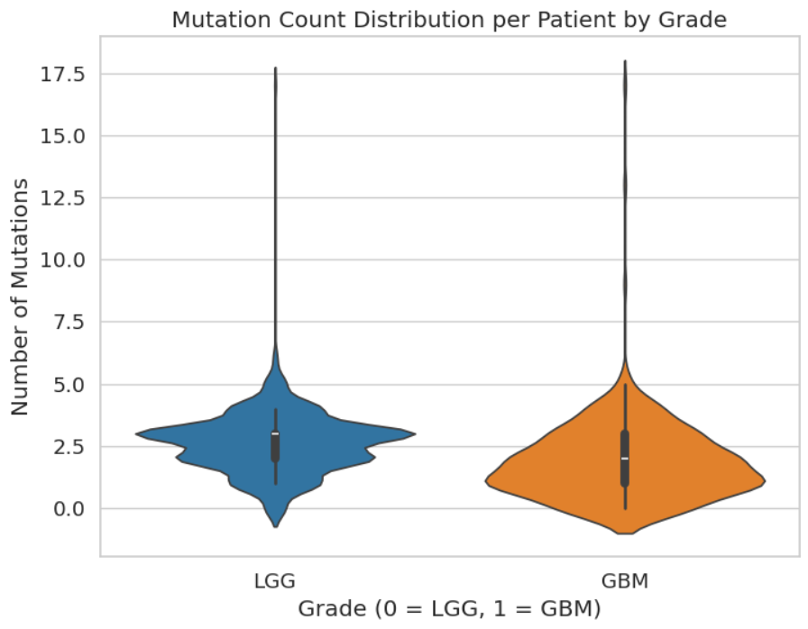

Objective 9: Feature Importance (Random Forest)
General Description: Feature contribution to grade prediction
Functions/Tools Used: RandomForestClassifier, feature_importances_
Result: Age and IDH1 were most important
Visualization: Bar chart of feature importance
X = df[['Age_at_diagnosis', 'Gender', 'Race'] + mutation_cols]
y = df['Grade']
clf = RandomForestClassifier(n_estimators=100, random_state=42)
clf.fit(X, y)
feature_importance = pd.Series(clf.feature_importances_, index=X.columns).sort_values(ascending=False)
plt.figure(figsize=(12, 6))
sns.barplot(x=feature_importance.index, y=feature_importance.values, palette='magma')
plt.title('Feature Importance for Glioma Grading (Random Forest)')
plt.xlabel('Feature')
plt.ylabel('Importance Score')
plt.xticks(rotation=90)
plt.show()
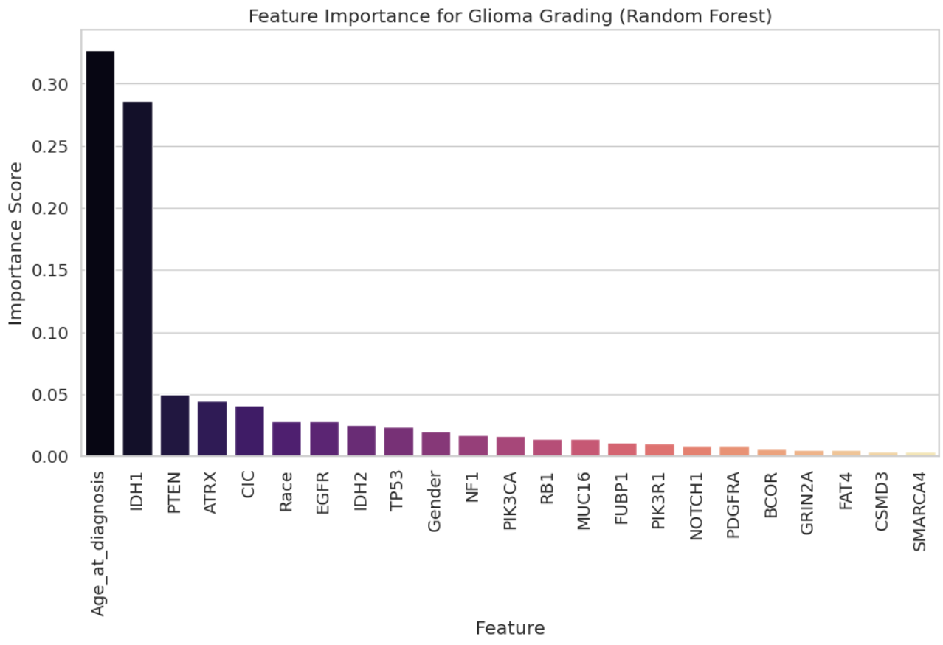

Objective 10: Gene Mutation Comparison between GBM & LGG
Result: Distinct mutation profiles observed between the two grades
Visualization: Line chart
gbm = df[df['Grade'] == 1][mutation_cols].mean()
lgg = df[df['Grade'] == 0][mutation_cols].mean()
plt.figure(figsize=(14, 6))
plt.plot(gbm.index, gbm.values, label='GBM', color='#ff7f0e', marker='o')
plt.plot(lgg.index, lgg.values, label='LGG', color='#1f77b4', marker='s')
plt.title('Gene Mutation Frequency: GBM vs LGG')
plt.xlabel('Gene')
plt.ylabel('Mutation Frequency (Proportion)')
plt.xticks(rotation=90)
plt.legend()
plt.grid(True, alpha=0.3)
plt.tight_layout()
plt.show()
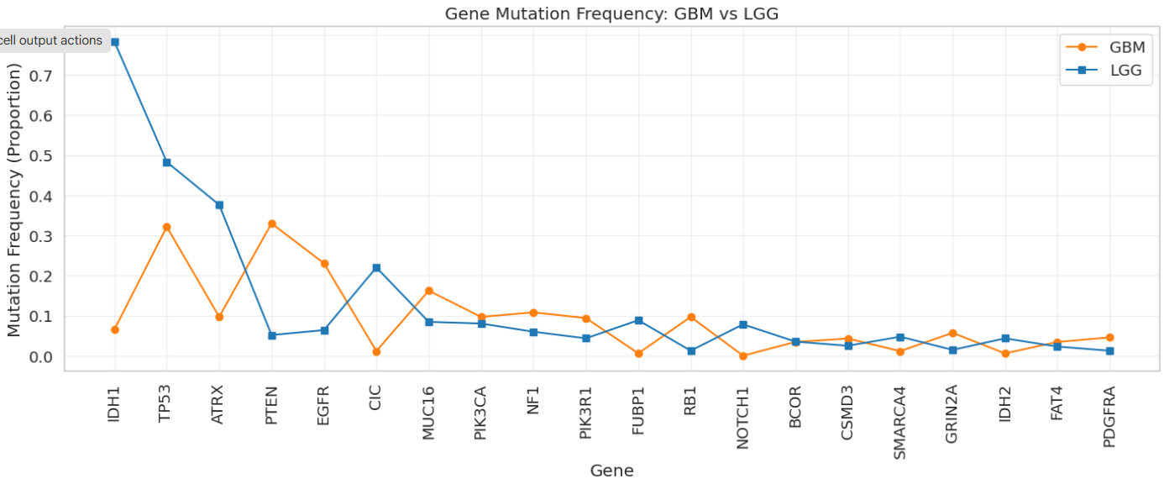

5. Conclusion
This project explored the relationship between clinical features and gene mutations in glioma patients. The analysis showed meaningful patterns between age, gender, mutation burden, and glioma grade. Visualizations effectively communicated trends and comparisons across groups.

6. Future Scope
- Incorporate survival prediction models using machine learning
- Extend to multi-class glioma grading
- Include treatment and outcome data for prognosis analysis
- Develop a web dashboard for real-time clinical decision support

7. References
- UCI Machine Learning Repository – Glioma Dataset
- Scikit-learn, Pandas, Seaborn, Matplotlib libraries
- Lovely Professional University – Course Resources
- Research articles on Glioma and Tumor Mutations

